SLE-3: Architectural Design – Maze Solving System

Course: 02AML204 – Introduction to Artificial Intelligence
PRN: 25UAM040
Name: Sanika Rajendra Pingale
Division: A
Date: 30/09/2026
Github link : https://github.com/pingalesanika872-bit

1.System Title & Short Description
Maze Solving System using BFS and DFS
The Maze Solving System finds a path from a starting point to a goal point in a maze. The user provides a maze, start position, and goal position. The system uses search algorithms such as BFS and DFS to explore the maze. It keeps track of visited cells and generates the final path as output.

2.Context Diagram (Level 1) :


The User provides the maze, starting point, and goal point to the Maze Solving System. The system processes the maze using BFS or DFS and finds a path to the goal. The solved path is then provided as the output to the User.

3.Container Diagram (level 2) :

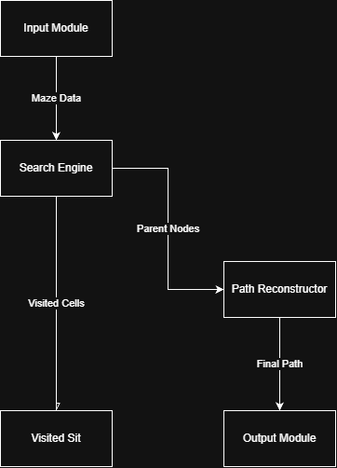

4.Component Diagram (level 3) :
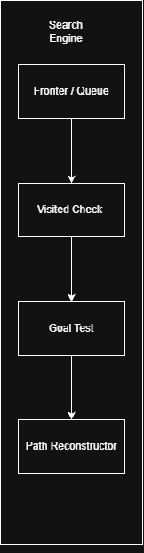

The Search Engine contains four main components. The Frontier/Queue stores cells to be explored, while Visited Check prevents repeated exploration. Goal Test checks whether the destination is reached. Path Reconstructor creates the final path from the search information.

5.Code Level Overview (Level 4) :
- class Node – Represents a cell/node in the maze.
- class Maze – Stores the maze, start position, and goal position.
- bfs() – Finds a path using Breadth First Search.
- dfs() – Finds a path using Depth First Search.
- is_valid() – Checks whether a cell can be visited.
- reconstruct_path() – Creates the final path from start to goal.

6.Design Decisions :
The system is divided into separate modules to make the architecture simple and easy to understand. BFS and DFS are placed inside the Search Engine because they perform the main search operation. The Visited Set helps avoid repeated exploration, while the Path Reconstructor creates the final path.

7.AI Contribution Note:
• AI tools used: ChatGPT
• What AI helped with: Understanding the C4 Model, planning the architecture, and preparing simple explanations.
• What I did myself: Selected the Maze Solving System, created the diagrams, prepared the report, and understood the system design.

8.Conclusion:
This SLE helped me understand software architecture using the C4 Model. I learned how the Maze Solving System can be represented using Context, Container, Component, and Code levels. I also understood how different parts of the system work together to find a path using BFS and DFS.

